Hydroclimate variations over the last 17,000 years as estimated by leaf waxes in rodent middens from the south-central Atacama Desert, Chile

Matías Frugone-Álvareza,b,c,∗, Sergio Contrerasa,e,∗, Oliver Meseguer-Ruizf, Eduardo Tejosa, Antonio

Delgado-Huertasg, Blas Valero-Garcésh, Francisca P. Díazi,b,j, Matías Briceñok, Manuel Bustos-Moralesk,

Claudio Latorrek,i,c,∗

*aUniversidad Católica de la Santísima Concepción, Departamento de Química Ambiental, Alonso de Ribera 2850, Concepción, Chile, 4090541*

*bANID-Millennium Science Initiative Nucleus (AFOREST), Vicuña Mackenna 4860, Macul, Santiago, Chile, 7820436*

*cANID-Millennium Science Initiative Nucleus (UPWELL), Raúl Bitrán 1305, La Serena, Chile,*

*dUniversidad Católica de la Santísima Concepción, Departamento de Química Ambiental, Facultad de Ciencias, Alonso de Ribera 2850, Concepción, Chile, 4090541*

*eCentro de Investigación en Biodiversidad y Ambientes Sustentables (CIBAS), Alonso de Ribera 2850, Concepción, Chile,*

*fUniversidad de Tarapacá, Departamento de Ciencias Históricas y Geográficas, Luis Emilio Recabarren 2477, Iquique,) Chile, 1101783*

*gInstituto Andaluz de Ciencias de la Tierra (CSIC-UGR), Av. de las Palmeras, 4, 18100 Armilla, Granada, Spain,*

*hInstituto Pirenaico de Ecología-CSIC, Quaternary Paleoenvironments and Global Change, Avda. Montañana, 1005, Zaragoza, Spain,*

*iInstituto de Ecología y Biodiversidad, Chile, Las Palmeras 3425, Ñuñoa, Santiago, Chile, 7800024*

*jPontificia Universidad Católica de Valparaíso. Instituto de Geografía, Avenida Brasil 2241, Valparaíso, Chile, 2362807*

*kPontificia Universidad Católica de Chile, Departamento de Ecología-Centro UC Desierto de Atacama, Av. Libertador Bernardo O’Higgins 340., Santiago, Chile,*

**Abstract**

*Leaf cuticular waxes are one of the most important environment-plant interaction structural systems that enable desert plants to withstand extreme climatic conditions. We present a long chain n-alkyl lipids study in fresh plant leaves and rodent palaeomiddens collected along an elevational gradient in the south-central Atacama Desert of Chile, covering six different vegetation belts: Steppe (4500-4,000 m asl), Puna (4000-3300 m asl), pre-Puna (3300-2400 m asl), Absolute Desert (2400-1000 m asl) and Coastal Desert (1000-0 m asl). The 28 rodent palaeomiddens analysed from Quebrada Incahuasi (25.6ºS, 3600 m asl) span the last 17,000 years. Modern-day distribution of long-chain n-alkanes and n-alkanoic acids varies among the dominant plant associations of the Atacama Desert. These plants show a species-specific chemotaxonomy linked to the climatic conditions. Furthermore, differences in average chain length (ACL) and carbon preference index (CPI) suggest that these plant communities are highly adapted to extreme environmental conditions. The sum of leaf wax n-alkanes was highest under wet conditions, while n-alkanoic acids (between n-C24 and n-C28) increased with hyperaridity. Similarly, analysis of n-alkane time series from palaeomiddens showed that the greatest changes in leaf wax n-alkane distributions (ACL and CPI) corresponded to the greatest increases in moisture during the Central Andean Pluvial Event (CAPE; between 18 and 9 ka cal BP) and the Late Holocene. The shift in the palaeomidden n-alkane distributions is corroborated by the relative abundance of rainfall-dependent extra-local taxa. This is the first study to report leaf wax content obtained from ancient rodent middens, and shows promising results as a robust hydroclimate proxy for the Atacama Desert region.*

*Keywords: Leaf cuticular waxes, Central Andes Pluvial Event, Chemo-taxonomy, Palaeoclimate, Pleistocene-Holocene transition*

**1. Introduction**

Establishing the magnitude and timing of climate changes that have modulated landscape dynamics in the past is part of the knowledge needed to achieve sustainable socio-ecological systems on a warming planet (Mucina, 2019; Berdugo et al., 2020). However, we do not know ecosystem’s nonlinear responses and thresholds to extreme and abrupt climatic variations, nor how these affect ecological adaptation and the configuration of landscape physiognomy (Berdugo et al., 2020; Eshel et al., 2021).

The central Andes, a natural laboratory for understanding biological responses to extreme environmental changes, has experienced pronounced hydroclimatic variations throughout the Late Quaternary that are unprecedented in the instrumental record (Arroyo et al., 1981; Betancourt et al., 2000; Grosjean, 2001; Latorre et al., 2002; Rech et al., 2002; Gayo et al., 2012; Stríkis et al., 2018; Rodbell et al., 2022). Nu-merous geological records from the western Central Andes have documented the impacts of at least four global/regional climatic changes during the last glacial termination. The Central Andean Pluvial Event (CAPE) (Latorre et al., 2006; Nester et al., 2007; Quade et al., 2008; Martin et al., 2018), subdivided into CAPE I (from ca. 18 and 14 ka cal BP, Gayo et al., 2012) and CAPE II (ca. 13 to 9 ka cal BP, Quade et al., 2008) was interrupted by a millennial-scale drought between c. 14-13 ka cal BP (Workman et al., 2020). A period of extreme aridity prevailed at the onset of the Middle Holocene (ca. 8-7 and 5-4 ka cal BP, Grosjean and Núñez, 1994; Valero-Garcés et al., 1996; González-Pinilla et al., 2021). A wet Medieval Climate Anomaly (MCA) between ca. 950 and 750 a cal BP (Lüning et al., 2019), relatively well described only in a few records was followed by drought at the onset of the Little Ice Age (LIA) ca. 650 and 100 a cal BP (Rabatel et al., 2008; González-Pinilla et al., 2021). It is not yet fully understood how these changes affected plant physiognomy, or how the landscape and biogeography have been reconfigured in response to climatic dynamics or whether, on the contrary, the distribution of species has remained relatively unchanged, maintaining the current floristic diversity (Díaz et al., 2012). The studies of sedimentary pollen sequences, plant macrofossil remains from palaeomiddens and climatic niche models show that Atacama ecosystems can be highly resilient to past climatic changes (Latorre et al., 2002; Anjos and de Toledo, 2018; Díaz et al., 2019). Palaeomiddens often contain remains of extra-local taxa (species outside their current distribution range) that coincide with periods or pulses of increased or decreased moisture. This suggests that local plant communities were rearranged in environments different from those found today (Latorre et al., 2002). This redistribution of species inferred from the geological record resulting from environmental changes, implies that Atacama plant communities exhibit greater plasticity than observed at present, capable of forming different plant assemblages that we do not currently find in these environments (Stotz et al., 2021; Navarro et al., 2022).

A plant’s photosynthetic structure is the best adapted to tolerate extreme environmental conditions. The leaves of Atacama plants, in particular, are highly specialized to withstand high levels of temperature, humidity, radiation, salinity, wind, and herbivory stresses (Eshel et al., 2021; Dussarrat et al., 2022). Cuticular waxes play a fundamental role in protecting plants from these stressors (Pollard et al., 2008). These waxes are mostly exuded from the leaves of plants and occur in small quantities (Eglinton, 1973). Chemically, leaf waxes are aliphatic hydrocarbon structures (mixtures of *n*-alkanoic acids, *n*-alkanes, *n*-alkanols, aldehydes and wax esters) highly persistent over time and have long been considered geochemical biomarkers of higher plants in the palaeoenvironmental record (Didyk et al., 1978; Bush and McInerney, 2013; Li et al., 2017; Inglis et al., 2022). The interest in leaf wax biomarkers is mainly due to the relationships that have been found between their molecular abundances and isotopic fingerprint with climatic and environmental changes (Sachse et al., 2006; Smith and Freeman, 2006). In the Atacama Desert, little is known about the composition and distribution of *n*-alkyl compounds (n-alkane and n-alkanoic acids) in plant communities and their relationship to past climatic changes (Mörchen et al., 2021; Contreras et al., 2022). The *n*-alkane abundance and distribution in different functional types of terrestrial plants show that *n*-*C*31 alkane predominates in grasses and *n*-*C*27 and *n*-*C*29 alkanes in woody plants (Bush and McInerney, 2013). Recent studies on *n*-alkanes in Atacama plants show a predominant distribution of long chains related to moisture sources rather than a chemo-taxonomic marker of the plants studied (Mörchen et al., 2021). Similarly, Contreras et al. (2022) found that *Tillandsia landbeckii*, a coastal fog-adapted CAM plant, exhibited significant negative correlations between the carbon preference index (CPI) of *n*-alkanoic acids and the average chain length (ACL) of *n*-alkanes in response to precipitation and surface evaporation. These results suggest that this species developed chemical adaptations to survive in low moisture conditions along the coast.

This research addresses whether it is possible to identify changes in aridity and detect the transgression of extra-local taxa in the landscape physiognomy by studying leaf *n*-alkane abundances in a series of palaeomiddens across major climatic transitions in the Atacama Desert during the last 17 ka cal BP. This study first measured the abundance and distribution in present-day leaf waxes of dominant landscape plants along an altitudinal transect from the coast to the Andes in the Atacama region. The *n*-alkanes from this vegetation were then used to compare the distributions and abundances of long chain *n*-alkanes obtained from a series of fossil middens for these reasons: 1) the *n*-alkanes are the most studied waxes in the palaeoenvironmental record, 2) they are found in high concentrations in the palaeomiddens, and 3) there are current studies of waxes from other places in the Atacama Desert with which to compare our results. In the following sections, we will describe the abundances and distributions of leaf waxes along an altitudinal gradient in the Atacama Desert, and then illustrate for the first time their application as a hydroclimate proxy in a series of palaeomiddens located in the south-central Atacama Desert, along a transition zone between a high elevation vegetation belt and absolute desert. Finally, we interpret and discuss the implications of changes in the abundance and distribution of leaf wax *n*-alkanes in the context of changes in the plant physiognomy of the Atacama environments and their contribution as a proxy for palaeoenvironmental reconstructions in arid zones.

**2. Material and methods**

*2.1. Site description and sampling*

The Atacama Desert extends over more than 128,000 km2 between the Pacific Ocean and the plateau of the western slopes of the Andes Mountains. The aridity and hyperaridity of the Atacama Desert are due to a combination of three main factors; rain shadow created by high Andes and Altiplano, the temperature inversions along the Pacific coast at ca. 1000 m asl and the blocking of moisture from westerlies by the South Pacific High. The plant richness pattern from the Atacama Desert is strongly related to environmental factors generating vegetation “belts” or zones (Villagrán et al., 1981; Díaz et al., 2016, 2019, Figure 1). We used these changes in plant physiognomy (Arroyo et al., 1981) to define six vegetation belts or zones (Steppe; 4500-4000 m asl, Puna; 4000-3300 m asl, pre-Puna; 3300-2400 m asl, Absolute Desert; 2400-1000 m asl and Coastal Desert; 1000-0 m asl) to categorize and characterize the leaf wax *n*-alkanoic acid and *n*-alkane abundance (Figure 1 and Table 1). Modern plant sampling was carried out in August 2018 during the dry season in the Atacama Desert. We collected fresh leaves of the dominant species in 15 sites along an elevational gradient from the coast (MAP; ~ 4 mm, MAT; ~ 14∘C) to 4300 m asl following the methodology described in Díaz et al. (2016) and Díaz et al. (2019). Plant cover was measured in the field by visual description where species were scarce and by the point-intercept method (four transects of 20 m length and 10 m spacing) where vegetation was more abundant (Braun-Blanquet et al., 1932). We selected the dominant species (at least 50% plant cover at each site) from each vegetation belt for wax analysis. Samples were collected using gardening gloves without directly touching the leaf part and placed in paper bags and then stored in glass jars in the laboratory. The plants were pressed and dried in the field, and later placed in a drying oven at 50∘C in the laboratory. We selected thirteen species for molecular analyses based on their abundance distribution within each zone [*Aloysia deserticola* (Rica-rica), *Atriplex imbricata* (Cachiyuyo), *Atriplex* sp., *Cristaria foliosa* (Malvilla), *Ephedra* sp. (Pingo-pingo), *Haplopappus rigidus* (Bailahuén), *Pappostipa frigida* (Paja brava), *Pappostipa* sp., *Junellia seriphioides* (Rosa de la cordillera), *Nolana aplocaryoides* (Suspiro), *Perityle emoryi* (Manzanillón), *Tiquilia atacamensis* (Kauchal)]. In 2017, we collected 28 rodent middens from Quebrada Incahuasi (QIN; 25ºC 35’ 52”S, 69ºC 14’ 18” W) located on the west hillside of the Domeyko mountain between 3530 and 3620 m asl (Table 2). In this area, Puna vegetation appears between 3200 and 4000 m asl and consists mostly of widely spaced shrubland plants; it is characterized by the shrubs *Junellia bryoides*, *Ephedra americana*, *Maihueniopsis* sp., *Cryptantha* sp. (Itallapa), *Pappostipa frigida*, *Baccharis tola* (Tola), *Haplopappus* sp., *Gilia* sp., *Cistante* sp., *Adesmia hystrix* (Arvejilla), *Phacelia cumingii* and *Phacelia pinnatifida* (Sobaco negro).

*2.2. Rodent middens and macrofossil analysis*

Fossil rodent middens were collected in October 2003 from Quebrada Incahuasi along ignimbrite overhangs and rock shelters. Quebrada Incahuasi (QIN) is an east-trending, short, narrow valley located above 3500 m asl. The valley heads into the Altiplano (Atacama Region) at over 4300 m asl. Large alluvial fans stem from the northern and southern ignimbrite cliffs and escarpments to the bottom of the valley. Middens were collected mostly along these escarpments. Vegetation in the valley is mostly contracted (i.e., mostly occurs in places along cliff walls or in the dry washes and other places where water accumulates) and is dominated by shrubs (*Junellia bryoides*, *Baccharis tola*, *Haplopappus rigidus*) and steppe grasses (*Pappostipa frigida*). Middens were processed following previously described procedures (Betancourt et al., 2000; Betancourt and Saavedra, 2002; Latorre et al., 2002). A modern analogue approach was used to control for the presence of extra-local species in the record; we collected all plant species present to within 500 m around each midden and compared these with the regional vegetation. Midden fecal-pellet sizes and shapes are used for distinguishing the midden-forming agents. Plant macrofossils were quantified and identified by comparison with the plants collected and a reference collection at the Laboratory of Palaeoecology and Palaeoenvironments of the Pontificia Universidad Católica de Chile. Taxa present in each midden were quantified with a relative abundance index (where 0 is absent and 5 is dominant, Spaulding, 1990). Approximately 100 mg of rodent feces from each of the 31 middens were submitted for 14C dating at the Accelerator mass spectrometry (AMS) laboratory at University of California Irvine (UC Irvine). Radiocarbon ages were calibrated using the SHCal20 calibration curve (Hogg et al., 2020) and reported in ka (thousands of calibrated years before present – defined as year 1950 CE).

*2.3. Extraction and quantification of* n*-alkanes and* n*-alkanoic acids*

The total lipid extract (TLE) was obtained using a Milestone Ethos Easy Microwave Assisted Extraction (MAE) system by extracting 0.5 g of dry leaf with 20 ml dichloromethane:methanol (DCM:MeOH) (9:1, v/v). 25 µL of an internal standard mixture of known concentration (containing 1000 ng/µL of cis−10−nonadecenoic acid, 5α−cholestane and nonadecanol) was added. The MAE was programmed with a ramp to 100ºC at 10ºC min –1, a hold time at 100ºC for 15 min, and a cooling time of 30 min. A blank was included in each sample set, to test for the presence of contaminants prior to sample analysis. The TLE was separated into three fractions using aminopropyl solid phase separation columns, eluting first with DCM:2-propanol (2:1, v/v) (*n*-alkane; neutral fraction), glacial acetic acid (GAA):ether (1:24, v/v) (*n*-alkanoic acid; fatty acid fraction) and MeOH at 100% (phospholipid fraction). The neutral fraction was eluted through activated (at 450 ºC) silica gel using hexane for *n*-alkanes. The *n*-alkanoic acids were derivatised with methanolic boron trifluoride (BF3:MeOH), forming fatty acid methyl esters (FAMEs). The *n*-alkanoic acids and *n*-alkane waxes were quantified using gas chromatography with flame ionisation detection (GC-FID 7890A; Agilent Technologies) and identified via GC–mass spectrometry (GC–MS:QP-5050A-Shimadzu) based on the retention time and spectra of standards for each compound. The temperature program started at 50ºC for 1 min, increased to 130ºC at 10ºC/min, then to 325ºC at 4ºC /min, and then remained isothermal for 15 min. Peak areas from GC-FID chromatograms were manually integrated to quantify the abundances by comparing with the area of a co-injected standard of known concentration (5-Androstane). Total *n*-alkane and *n*-alkanoic acid concentrations in g/g dry weight (dw) were calculated as the sum of *n*-C21 to *n*-C33 and *n*-C22 to *n*-C34 (odd as well as even ones), respectively. The *n*-alkanoic acids and *n*-alkanes leaf wax abundance was calculated per unit dry leaf mass (*µ*g/g). The leaf wax distribution wascalculated using the ACL and CPI for *n*-alkanoic acids and *n*-alkanes or all samples as shown below:

$$

ACL_{(a-b)} = \sum\limits_{i=a}^{b}\frac{i\cdot {C_{i}}}{C_{i}}

$$

where (a − b) and Ci indicate the range and the concentration of odd and even chain lengths for n-alkanes (ACL(23−33)) and n-alkanoic acids ACL(24−34), respectively.

$$

CPI_{(alkanes)} = 0.5 \cdot \left[(\frac{\sum C_{even}}{\sum C_{odd}}) + (\frac{\sum C_{even}}{\sum C_{odd}})\right]

$$

$$

CPI_{(FAME_{s})} = 0.5 \cdot \left[(\frac{\sum C_{odd}}{\sum C_{even}}) + (\frac{\sum C_{odd}}{\sum C_{even}})\right]

$$

Ceven (carbon 24 to 32) and Codd (carbon 23 to 33) indicate the carbon-chain length abundance even and odd, respectively.

*2.4. Data analysis*

To study the relationship between *n*-alkyl lipid total abundances and climate, we use the CR2MET gridded product which contains regional precipitation, average temperature, minimum temperature and maximum temperature values with a resolution of 0.05 degrees (https://www.cr2.cl/datos-productos-grilados/). We calculated 19 bioclimatic layers that were used to evaluate different predictive supervised models of *n*-alkanes from no more than 3 input parameters. The sensitivity was evaluated through the bootstrapping method. Random Forests (RF) correlations were applied using the scipy library in Python3.4. We carried out redundancy analyses (RDA) to quantify the relationship between *n*-alkanes and macrofossil from rodent middens in the R package ‘vegan’ v4.2.2 using RStudio v12.0 (see ‘Data availability’ section). The *tidy data frames* format for data analysis and graphics were performed using the R packages; ‘tidyverse’ v1.3.2,‘tidypaleo’ v1.3.9,‘rioja’ v1.0-5 and ‘ggplot2’ v3.4.1 (Wickham et al., 2019; Dunnington et al., 2022; Juggins, 2022; Wickham, 2016).

**3. Results**

*3.1. Abundance and distribution of long-chain (>C21)* n*-alkyl leaf waxes along an environmental gradient in the Atacama Desert.*

The vegetational gradient was dominated by twelve species (~80% landscape); *Pappostipa frigida* (Paja brava), *Atriplex imbricata* (Cachiyuyo), *Haplopappus rigidus* (Bailahuén), *Ephedra americana* (Pingo pingo), *Aloysia deserticola* (Rica-rica), *Junellia seriphioides* (Rosa de la cordillera), *Tiquilia atacamensis* (Kauchal), *Cristaria integerrima* (Malvilla), *Nolana aplocaryoides* (Suspiro), *Perityle emoryi* (Manzanillón) and two unidentified species in the coast (see Table 1S and Figure 1S). Figure 1 shows the climatic correlations with individual abundances of each long-chain *n*-alkyl (*n*-alkane and *n*-alkanoic acids) leaf wax. Total leaf wax abundance showed a strong second-degree correlation (R2= 0.86 ± 0.11) with altitudinal cline (Figure 1 b). Additionally, these results showed positive correlations with annual mean, annual mean maximum, and annual mean minimum temperature, and negative correlations with annual mean precipitation (Figures S3 and S4). The long chains between *n*-C26 and *n*-C29 showed the highest correlation (between R2 = 0.4 and R2 = 0.6) values in all the variables analyzed (see Figures 2S and 3S). In general, we observe a high variability of total abundances in the chain-length of waxes within and between vegetation belts (Figure 1 and Figure 2S). The concentration of *n*-alkyl foliar waxes tends to be higher in the Coastal, pre-Puna and Puna zones compared to the Hyperarid and Steppe, which have the most extreme environmental conditions (Figure 1 a and Figure 2S). The highest abundances of *n*-alkyl waxes occur between 50-200 and 2500 to 3700 m asl, coincident with zones of the greatest species richness and abundance. The lower individual molecular abundances were observed in the Hyperarid core (~2000 to 2300 m asl) and high Andean altitude (4000 to 4400 m asl). The odd-over-even and even-over-odd chain-length distributions of *n*-alkanes and *n*-alkanoic acids were more abundant between *n*-C25 to *n*-C31 and *n*-C24 to *n*-C30, respectively (Figure 2 a). The leaf wax *n*-alkanes and *n*-alkanoic acids abundance of surface sediment from two brackish lakes in the Atacama Altiplano (Miscanti and Miñiques lakes at 4200 m asl) showed similar total abundance values to the Steppe but different distribution i.e. CPI and ACL (fig-2 b). The leaf wax *n*-alkanoic acids (n=3) and *n*-alkanes (n=6) abundances in these lake sediments were of 375.88 ± 52 g/gdw (CPImedian = 11 ± 2.6; ACLmedian = 24.25 ± 0.07, Table 1) and 10.45 ± 5 µg/gdw (CPImedian = 9 ± 1.98; ACLmedian = 25.92 ± 0.63, Table 1S), respectively. In sedimentary *n*-alkanoic acids, carbon chain-lengths show higher abundance of medium carbon chain length between *n*-C22 and *n*-C24. The high and medium molecular weight ranges are the minority (*n*-C26 to *n*-C32) and represent ca. 20% of the *n*-alkanoic acids in the sediments. For n-alkane, carbon chain-lengths distribution is between *n*-C23 and *n*-C33 with a higher abundance of medium and high molecular weight (*n*-C23 and *n*-C29), but their relative abundances were lower than n-alkanoic acids (Figure 2).

*3.2.* n*-Alkanes and plant macrofossils from rodent middens in the Atacama Desert over the last 17,000 years*

A total of sixteen different plant taxa were identified covering twelve families; fifteen genera and five species of plant macrofossils (Table 1). Radiocarbon ages from 28 rodent middens reveal a temporal coverage for the last 17 ka cal BP (Table 2). Fecal-pellets indicate that the middens were made mainly by the ashy chinchilla rat (*Abrocoma cinerea*) and by leaf-eared mice (*Phyllotis* spp.). In the modern midden 208-B (150 ± 90 cal yr BP at 3592 m a.s.l., south slope; Table 2) we find macro-remains of *Haplopappus* sp., *Junellia bryoides*, *Gilia* sp., *Cistanthe* sp., *Phacelia cumingii*, *Phacelia pinnatifida*, *Cryptantha* sp. and *Ephedra americana* —a composition similar to the species collected in the field (*Haplopappus* sp., *Junellia bryoides*, *Gilia* sp., *Cistanthe* sp., *Phacelia cumingii*, *Phacelia pinnatifida*, *Cryptantha* sp. and *Ephedra americana* besides *Maihueniopsis* sp., *Baccharis tola* and *Pappostipa frígida*). Among taxa identified at the site, we note that some are quite scarce with slope exclusivities, such as *Maihueniopsis* sp and *Baccharis tola* on the north slope and *Pappostipa frígida* on the south slope.

A diagram of the relative abundances of each taxon along with the chronology obtained with AMS 14C dating (Table 2) is shown in Figure 3. The middens were dominated by the local taxa *Junellia bryoides*, *Cistanthe* sp., *Ephedra americana* and *Phacelia cumingii*. At ca. 17 ka cal BP, the record shows the presenceof only two local taxa (*Junellia bryoides* and *Phacelia pinnatifida*) and one extra-local taxa (*Adesmia* sp.). Between ca. 15.5 and 10 ka cal BP, the record shows an increase in local plant richness and extra-local species such as *Stipa frígida*, *Adesmia* sp, *Malvaceae*, *Chenopodiaceae*, *Baccharis aff tola* and *Brassicaceae aff Atacamanivea*. A large group of middens between ca. 10 and 3 ka cal BP shows a decrease in plantrichness with an increase in the annual extra-local Malvaceae family. From 3 to 0.18 ka cal BP, there are increases in the local taxa richness dominated by *Junellia bryoides* and *Cistante* sp. with the appearance of *Haplopappus* sp. and *Cryptantha* sp., among others.

The rodent middens contain high wax values spread with a total mean *n*-alkanes abundance of 335.4 ± 239 µg/gdw (n=24, CPImedian = 18.46 ± 5.44; ACLmedian = 29.12 ± 0.4, Table 1S and Figure 4). The chain-length distribution in middens was between n-C21 and n-C35 with a higher abundance of n-C27 to n-C31 chain and predominance of carbon chain length n-C29. Fecal-pellet δ13C values show a range from-21.3 to -25.4 ‰ with a median of -23 ‰. The palaeomidden dated to ca. 17 ka cal BP showed a lower abundance in all chain-length distributions. One of the main features of the middens dated to ca. 15.2 ka cal BP and between 14 and 12 ka cal BP was the high n-alkanes abundances of longer chains (*n*-C25 to *n*-C35) compared to the chain-length abundance between ca. 11 and 5 ka cal BP. The abundances of *n*-alkanes for the youngest samples dated between 5 and 0.18 ka cal BP shows an increase in all chain-length distribution, where the midden with higher *n*-alkanes abundance was at ~ 4 ka cal BP (Figure 3). Remarkably, the midden dated at 11.7 ka cal BP has the highest concentration of *n*-alkanes in the record (~1000 g/gdw), where the carbon length chain *n*-C29 dominates. Two grass samples, dated between 970 (QIN237 B) and 11,780 (QIN214b) a cal BP, extracted from the palaeomiddens matrix showed high n-alkane values.

4. Discussion

4.1. Distribution of leaf wax n-alkanes and n-alkanoic acids along an altitudinal transect (50–4200 m a.s.l) in the Atacama Desert

The leaf wax *n*-alkanes and *n*-alkanoic acids along the vegetational transect in the Atacama desert show a species-specific and heterogeneous distribution in the chain lengths (Figure 1 and Figure 2). Leaf waxes from Steppe and Puna species have a clear predominance of *n*-C29/*n*-C28 chain lengths in n-alkanes and n-alkanoic acids, respectively. On the other hand, the pre-Puna showed a higher abundance on *n*-C27/*n*-C26 and *n*-C29/*n*-C28 chain lengths. At the coast —where advected fog plays an important role as a moisture source— we found equal abundance of *n*-C29 and *n*-C27, while the plants from the Hyperarid Desert showed two different and antagonistic wax distributions where predominate *n*-alkane *n*-C31 and a higher n-alkanoic acids abundances of medium chain lengths (Figure 2). Mörchen et al. (2021), found for different plant species of the Atacama Desert that the *n*-alkane abundances showed a predominance of chain lengths *n*-C27 and *n*-C31.

These authors related the higher *n*-alkanes production to the influence of the sources of moisture coming either from coastal fog or summer precipitation in the Andes. Contreras et al. (2022) provided a detailed assessment of Tillandsia landbeckii leaf waxes (a CAM species highly specialized to living only off fog), describing a homogeneous *n*-alkanes distribution that ranged from *n*-C23 and *n*-C31 where the leaf wax distribution (ACL and CPI index) showed a higher inverse correlation with moisture availability. On the northwestern slope of the south-central Andes of Argentina, soil *n*-alkanes showed a higher abundance and unimodal distribution along an altitudinal transect of the chain lengths *n*-C27, *n*-C33 and *n*-C29 (Nieto-Moreno et al., 2016). While the tropical forest from Kosñipata valley in Perú, (Feakins et al., 2016) showed a predominance of *n*-C29 and *n*-C31 chains followed by *n*-C27 and a poor relationship between temperature and leaf wax distribution. Wu et al. (2019), in another elevation gradient between the Amazon floodplain and the eastern flank of the Andes in Peru, found a dominance of chain lengths *n*-C29 and *n*-C31 with a higher *n*-C31/*n*-C29 ratio at lower elevation sites. And Teunissen van Manen et al. (2020) observe this same relationship in leaves and soil in Ecuador. All these studies above show that the proportions in the chain lengths of *n*-alkanes are highly variable at ecosystem-dependent scale.

Biotic and abiotic stresses can induce metabolic and biosynthesis responses in cuticular waxes (Shepherd and Wynne Griﬀiths, 2006; Lewandowska et al., 2020). In the Atacama Desert, one of the harshest terrestrial environment conditions on earth, *n*-alkanes and *n*-alkanoic acids from leaf-wax show a strong relationship to vegetation belts (Figure 1). We observed a higher total abundance of individual chains of *n*-alkanes and *n*-alkanoic acids in zones where the plants have more moisture available coming from the coast and seasonal summer rains (Arroyo et al., 1988). Atacama vegetation is adapted to prolonged drought conditions, mechanical stress, low nutrient availability, and high levels of radiation, salinity, and metals along the altitude gradient (Díaz et al., 2016; Rondanelli et al., 2015; Eshel et al., 2021). Several studies show significant cor-relations between n-alkane distributions with temperature and precipitation (Hoffmann et al., 2013; Tipple and Pagani, 2013; Feakins et al., 2016; Wang et al., 2018), while others show a weak or null relationship with climatic variables (Carr et al., 2014; Howard et al., 2018). Mörchen et al. (2021) and Contreras et al. (2022), argue that *n*-alkanes from fog-fed plants in the Atacama that receive coastal moisture show a dominance of *n*-C31, *n*-C29, *n*-C33 and *n*-C27 chain lengths, whereas plants affected by summer rainfall show a greater abundance of *n*-C31 and *n*-C29 chain lengths. The n-alkane distributions along the Atacama Desert suggests a strong relationship with the available moisture conditions in the vegetation belts, which should be evaluated before using the leaf waxes as an indicator of paleoenvironmental change.

4.2. Sources n-alkane leaf wax in a 17,000 yr long rodent midden record from Atacama Desert

The analysis of *n*-alkanes in rodent coprolites from middens show a marked distribution range of chain length between *n*-C21 and *n*-C35 with a greater abundance of *n*-C29 followed by *n*-C31 (Figure 4). These wax distributions are similar to those found in plants that dominate the Steppe and Puna, where species such as Pappostipa frigida, Haplopappus rigidus and Junellia seriphioides have a greater abundance of *n*-C27, *n*-C29 and *n*-C31. In the Steppe, where Pappostipa frigida dominates the landscape, the fingerprint of chain length is the *n*-C29. When we compare the n-alkanes from grasses inside two rodent middens matrix with the n-alkanes obtained from their fecal-pellet (QIN237-B and QIN214-B; ca. 970 and 11,780 a cal BP, respectively), we note a similar pattern between their distributions (Figure 5S), but with concentrations that are one to two orders of magnitude lower —50/16 µg/gdw in grasses compared to 368/1054 µg/gdw in fecal-pellet (Figure 4). Latorre et al. (2002), studied the relationship between vegetation and dietary behavior by analyzing cuticles in feces from 41 rodent middens during the last 45 ka cal BP of the pre-Puna of the Atacama Desert. This comparative study between plant macrofossil, abundance of grasses and leaf wax analysis showed that the diets of different rodent species are closely related to the surrounding vegetation, however, we cannot rule out that the dietary preferences and collecting behaviors can introduce bias into midden records (Borrelli and Holmgren, 2016). Our fecal-pellet isotopic analysis shows δ13C values close to -23 ‰ that are indicative of an almost pure C3 diet (Latorre et al., 2002). This is consistent with our RDA analysis between plant macrofossil and n-alkane abundance, which separates the abundances of *n*-C29 and plant extralocal from *n*-C31 and local taxa of the pre-Puna (Figure 6S). Based on our observations, we predict that a higher abundance of plant species in the landscape will lead to increased variation in chain length distributions in palaeomiddens. In addition, we expect to see a pronounced dominance of of *n*-C29 during periods of increased grass abundance. This observation can be explained by the presence of species-specific chemotaxonomic biomarkers and the generalist dietary behaviour of rodents (Latorre et al., 2002; Borrelli and Holmgren, 2016).

4.3. Leaf wax n-alkane in rodent midden record as proxy of palaeoenvironmental changes

Palaeomidden records from the central Atacama (15º to 27ºS), contain many extra-local species indicative of past pluvials in the south-central Andes during the Quaternary (Betancourt et al., 2000; Rech et al., 2002; Latorre et al., 2006; Díaz et al., 2019). At least six pluviometric anomalies have been linked with vegetation changes in the Atacama; CAPE I (ca. 18 to 14.8 ka cal BP), CAPE II (ca. 13.0 to 8.6 and 8.1 to 7.6 ka cal BP) and four relatively short-period pluvials during ~ 4 to 3.4, ~2.5, MCA (ca. 1.2 and 0.8 ka cal BP) and LIA (ca. 0.5 and 0.1 ka cal BP). Low latitude insolation changes and/or strengthening/weakening of the South American Monsoon System and precipitation from the maritime weather system —forced by ocean-atmosphere dynamics of the Pacific and/or Atlantic— are the most common climatic teleconnections proposed to explain these precipitation anomalies (Betancourt et al., 2000; Rech et al., 2002; Gayo et al., 2012; González-Pinilla et al., 2021).

Can the *n*-alkanes obtained from palaeomidden records reflect niche shifts in the Atacama plant communities during the past? The leaf wax *n*-alkane chain-length distributions of the plants studied show a clear species-specific molecular signature associated with the different vegetational belts (Figure 2S). High Andean Steppes from Atacama are represented mainly by *n*-C29 and *n*-C31 n-alkanes. At the same time, environments in lowlands (pre-Puna and Puna) are characterized by a greater diversity of chain lengths lengths between *n*-C22 to *n*-C33 due to the different species that live there. These molecular relationships could be used to detect wax input due to extra-local species in ancient Atacama ecosystems. In that regard, rodent palaeomiddens can be an excellent tool to understand the relationships between wax production and plant species that lived at a given time. Plant macrofossils analysis from modern middens dated around 150 cal a BP (3592 m asl, Figure 3) from pre-Puna showed a composition similar to the species collected in the field (*Haplopappus* sp, *Junellia bryoides*, *Gilia* sp, *Cistanthe* sp, *Phacelia cumingii*, *Phacelia pinnatifida*, *Cryptantha* sp. and *Ephedra americana*). In the same manner, as observed in the Puna and pre-Puna, the *n*-alkanes chain lengths obtained from fecal-pellets in these modern middens are dominated by *n*-C25, *n*-C27 and *n*-C33 whereas *n*-C29 and *n*-C31 are co-dominants. Furthermore, when we analyze the *n*-alkane distributions across all palaeomiddens over the last 17 ka cal BP, the data show a high variability in n-alkane chain lengths (Figure 4). We propose that these heterogeneous *n*-alkane distributions represent a response to changes in the climate and species composition of the Pre-puna where the palaeomiddens are generated. That idea is supported by the redundancy analysis (RDA) where the extra-local species are with *n*-C25, *n*-C27 and *n*-C29 *n*-alkanes (Figure 6S) and by the link between the *n*-alkane distributions of grassesand fecal-pellets found in the middens QIN237-B and QIN214-B (Figure 5S). This suggests that the Atacama Desert plants have a suﬀiciently high molecular plasticity to overrun ecosystems different from the current, as shown by some recent studies in these extreme habitats (Díaz et al., 2019; Eshel et al., 2021; Dussarrat et al., 2022). To test this assumption, we compare our *n*-alkanes palaeomidden series with different climate change records associated with flood variations in the Atacama Desert (Figure 5).

During the CAPE I, palaeomidden records show an increase of extra-local species, together with *n*-C25, *n*-C27, *n*-C29 and *n*-C33 n-alkanes (Figure 4 and Figure 5 a-d). According to the current distribution of chain lengths in the Atacama Desert, this increase could represent greater biodiversity of plants from different vegetation belts. González-Pinilla et al. (2021), reconstructed positive mean annual rainfall (MAR) anomalies in the Atacama Desert at 15.9 to 14.8 ka cal BP (MAR = 142 ± 10), 13.0 to 8.6 ka B.P (MAR = 130 ± 18) and more variable precipitation during the Late Holocene (Figure 5 f). They associated the MAR anomalies from CAPE I to the Heinrich Event 1 (HE-1) and La Niña-like conditions inferred from El Niño flood activity record in Perú (Rein et al., 2005) that drove an intensification and southward shift of the South American Summer Monsoon (SASM). These moisture changes are coeval with those observed in the n-alkanes of the midden series (Figure 5 f). In contrast, in the western Central Andes lake records (Figure 5 h-g), there are low lake levels at lakes of Miscanti, Chungará and Junín during this phase, which have been associated with the weakening of the SASM and the hydrological balance of the upper Amazon basin and the Altiplano (Valero-Garcés et al., 1996; Moreno et al., 2007; Rodbell et al., 2022). During the CAPE II, the n-alkanes show an initial increase in n-C31 chain length followed by an abrupt increase in *n*-C29 during the end of the YD (at ca. 10.8 ka cal BP) followed by fluctuations of the *n*-C27 n-alkane (Figure 5). Between the CAPE I and CAPE II phases (ca. 14.8 and 13.1 ka BP), the decrease of n-alkanes are indicative of dry conditions that coincide with the Bölling/Allerød (BA) warming period and the Meltwater Pulse 1A (MWP-1A) occurred around 14.6 ka (Liu et al., 2009; Obase and Abe-Ouchi, 2019; He and Clark, 2022). These data support the assumption of a very dry period by González-Pinilla et al. (2021) between 14.8 and 13.1 ka B.P. However, high lake levels in the western central Andes (Figure 5 g-f) during this period suggest a seesaw response of the SASM, possibly related to meridional shifts of the Intertropical Convergence Zone (ITCZ) forcing by Atlantic Meridional Overturning Circulation (AMOC) and North Atlantic SST variability during the last deglaciation (Fornace et al., 2014, see Figure 5 j). A weaker AMOC reduces northward energy transport, leading to cooler North Atlantic SSTs. This can cause the ITCZ to shift southward, as it tends to follow the region of maximum SSTs and associated convection. A southward shift of the ITCZ in turn affects the strength and position of the South Atlantic Subtropical Anticyclone and the position of the trade winds in the tropical Atlantic, leading to a redistribution of rainfall within the tropics and subtropics, with less rainfall further north and more rainfall further south (Schneider et al., 2014; Houston and Latorre, 2022). However, the direct impact of the AMOC on the Atacama Desert is likely to be limited. This apparent disagreement could be explained by different sources of oceanic and continental moisture along the Andean Dry Diagonal, where ENSO-like conditions could play a predominant role (see Houston and Latorre, 2022).

Stable deuterium and carbon isotope analyses of individual long-chain *n*-alkanes from palaeomiddens could give us clues about the mechanisms at work in the Atacama Desert. In the Middle Holocene, the palaeomidden record shows a greater abundance of *n*-C29 and *n*-C27 chain lengths typical of grasses, while during the Late Holocene the differences in abundances among the n-alkanes decrease. Several authors have described arid conditions in the Atacama Desert during the Middle Holocene (Grosjean and Núñez, 1994; Valero-Garcés et al., 1996; Betancourt et al., 2000; Núñez et al., 2002), the timing and lapse of this aridity condition are still under discussion (Grosjean, 2001; Latorr e et al., 2002; Rech et al., 2002), where La Niña-like conditions and spatially complex SASM system precipitation are the main characteristics (Rein et al., 2005; Wong et al., 2021). Finally, during the Late Holocene the n-alkanes chain lengths are co-dominant and represent the present-day plant communities, where climatic variability could only partly explain present-day chain length distributions if we consider other factors such as species introduction by human activity.

5. Conclusions

This work demonstrates how the abundance of leaf waxes and records of climate change obtained from palaeomiddens are related to vegetation change in the Atacama. The *n*-alkanes and *n*-alkanoic acids from current plant leaf waxes show a high variability through the elevational gradient and a species-specific molecular signature of these vegetational belts. The Steppe is characterized by high abundances of of *n*-C29 chain length followed by *n*-C31 and *n*-C27, respectively. Leaf waxes from the Puna and Pre-puna have a greater abundance and diversity of chain lengths, whereas in the absolute desert the most abundant *n*-alkanes and *n*-alkanoic acids are the *n*-C31 and *n*-C22 chains. Along the coastal Atacama, the *n*-alkanes that predominated are *n*-C27 and *n*-C29 in contrast with a decrease of the *n*-alkanoic acids that are dominated by *n*-C28 and *n*-C26 chains. We observe a decoupling of leaf wax ACL values between *n*-alkanes and *n*-alkanoic acids in the absolute desert. Biochemical differences between *n*-alkanes and *n*-alkanoic acids ACL values could imply different hydric-deficit tolerance strategies in plants under hyper-extreme environmental conditions. In general, our study shows that palaeomiddens are an excellent source of leaf wax abundances in the pre-Puna of the Atacama and respond to different moisture pulses previously identified in the region. As described in other research, the palaeomidden record indicates increased wet conditions during the CAPE phases consistent with lower summer insolation and increased humidity modulated by ENSO and SASM. Furthermore, palaeomiddens show a dry period between ca. 13 and 14.8 ka cal BP co-occurring during a strengthened AMOC and abrupt increase in grasses at 11.7 ka cal BP as indicated by increased abundance of *n*-C29 chain length. Lower bioproductivity could be interpreted during the Early and Middle Holocene (from ca. 11.0 to 6.0 ka cal BP), coincident with a decrease in precipitation described for the Atacama. Multiple interrelations between solar irradiance, climate, nutrient and vegetational changes could be controlling the abundance of waxes in time, and other proxies should be used to confirm this relationship. However, more comprehensive leaf wax analysis of the dominant vegetation and other midden series are required to better understand and quantify the link between climatic variability and n-alkyl leaf waxes under extreme arid environmental conditions. These records create an opportunity to complement other palaeoclimate proxies with isotopic analysis and genetic information across a wide spatial range to understand the complex relationships between climate and desert vegetation where other palaeoclimate records are scarce.

6. Data Availability

All raw data and code used in this paper are publicly available for reuse via Zenodo (doi:10.5281/zenodo.7768860) and Github (https://github.com/mat1506/atacama.waxes.git)

7. Acknowledgments

We thank Chris Moy, Jean Pierre Francois, Hector Orellana, the indigenous community of Socaire and CONAF for help with sample analysis and logistical support in the field.

8. Financial support

This research was supported by the ANID-FONDECYT (grants 1190398, 1191568, 11220930, 3180368). Additional support was provided by the Millennium Science Initiative Program Nucleus AFOREST (NCS2022_24) and the Millennium Science Initiative Nucleus UPWELL (NCN19-153) of the Ministry of Economy, Development and Tourism (Chile) and IEB (through ANID FB210006).

9. CRediT authorship contribution statemen

The authors declare that they have no conflict of interest.

10. Tables

Table 1: Macrofossils identified, including their family, type and phytogeographic aﬀinity.

Table 2: Site location, radiocarbon dates, calendar year BP (95.4% probability ranges; curve Shcal20, Oxcal 4.4) and former agent for 28 rodent middens analyzed (see Fig. 1 for midden localities). SD: standard deviation, *:Unidentified

11. Figures

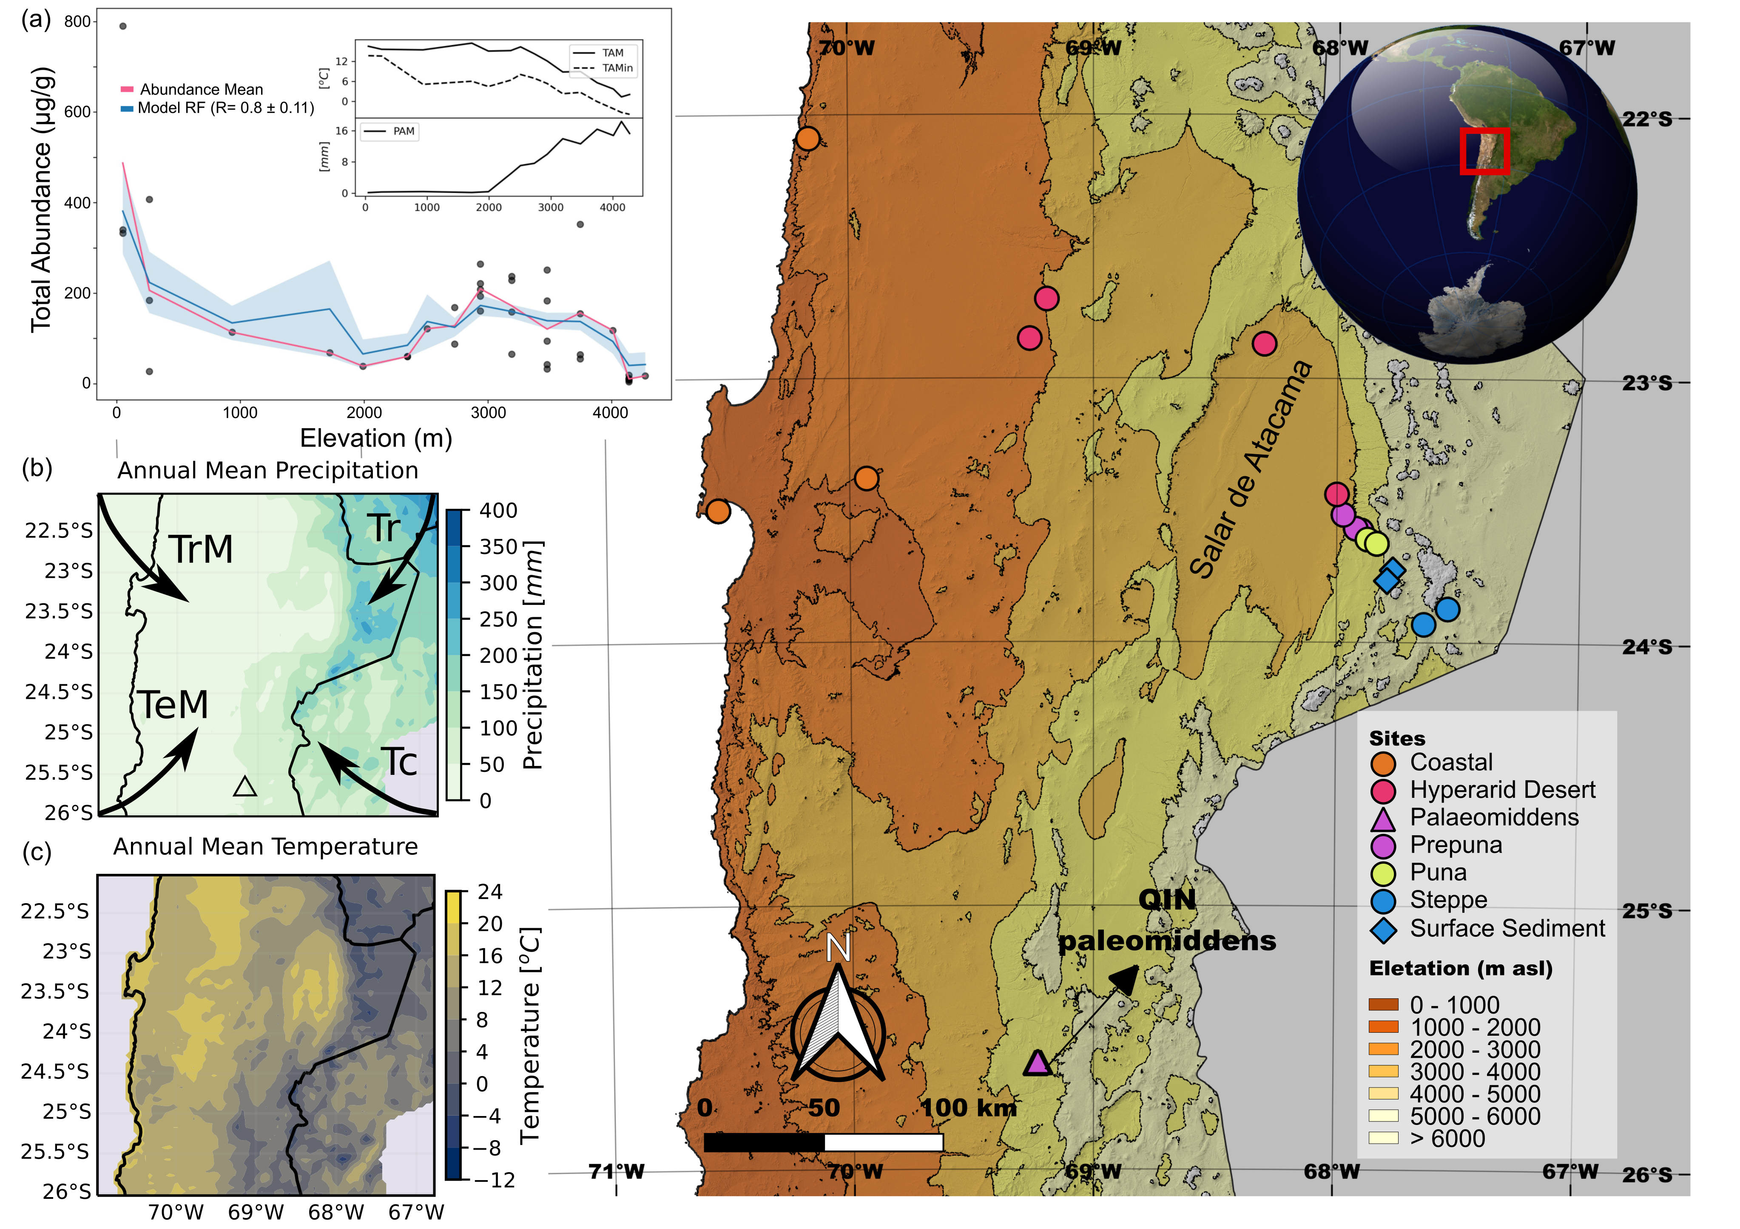Figure 1: Figure 1: Local and regional context of vegetational and palaeomiddens site in the southern Central Andes in the Atacama Desert, Chile. (a) Random forests (RF) correlations between total abundance (µg/g) of n-alkyl lipids (n-alkanoic acids and n-alkanes of plants and lacustrine surface-sediments of Miscanti and Miñique lakes) and climatic features (precipitation and temperature) along an elevation gradient of the Atacama Desert. (b) Mean Annual Precipitation and sources of air masses that contribute moisture to the Atacama Desert and Western Cordillera of the Andes (TrM: tropical maritime source; TeM: temperate maritime source; Tc: temperate continental source and Tr: tropical continental source. Modified from Houston and Latorre, 2022) and (c) Annual Mean Temperature.

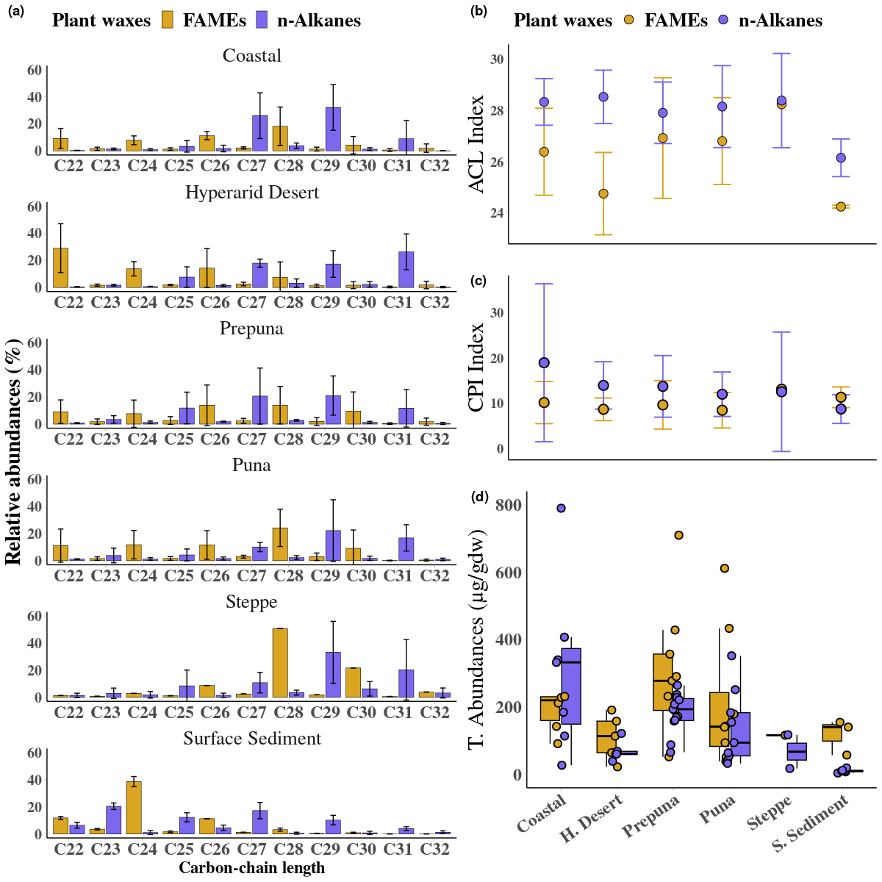Figure 2: Abundance and distribution of leaf waxes (*n*-alkanoic acids and *n*-alkanes) along an environmental gradient in the Atacama Desert (Coast, Hyperarid Desert, Pre-Puna, Puna, Steppe and superficial lacustrine sediments of two high Andean steppe lakes). (a) average chain length (ACL), (b) carbon preference index (CPI), (c) Total Abundances and (d) percentage distribution of long-chain of leaf waxes from twelve species of Atacama Desert.

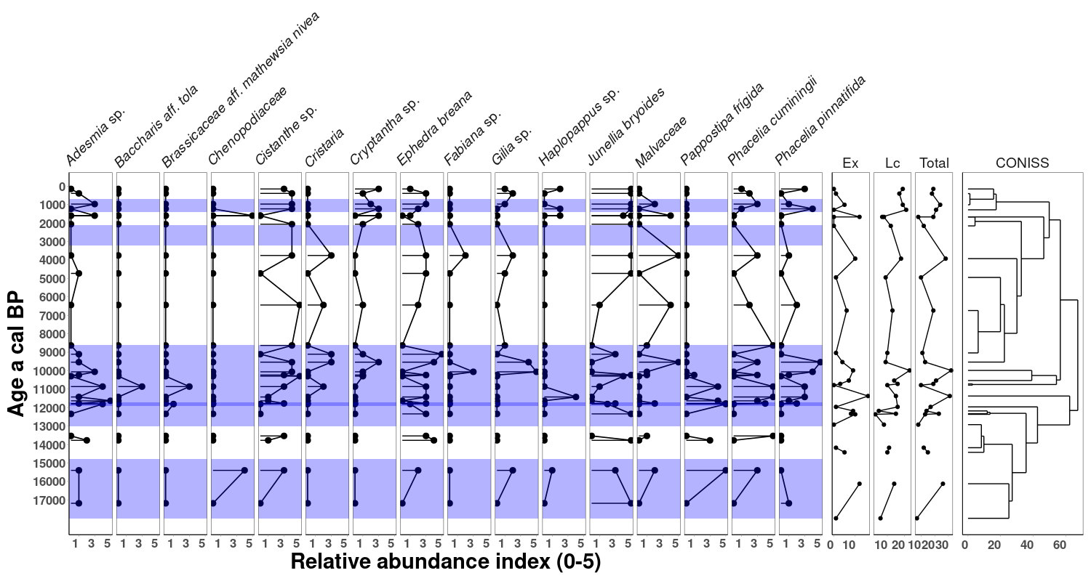Figure 3: Plant macrofossil diagram from palaeomiddens in Quebrada Incahuasi. Relative abundance index runs from 0 (absent) to 5 (dominant). Modern analogue groups of local and extralocal taxas have been defined. Ex: total number of extra-local species, Lc: total number of local species and “Total”: represents the total number of species. A CONISS analysis was performed to see the relationships between the samples. The purple bands represent of the pluviometric anomalies CAPE I (ca. 18 to 14.8 ka cal BP), CAPE II (ca. 13.0 to 8.6 and 8.1 to 7.6 ka cal BP), ~2.5 and MCA (ca. 1.2 and 0.8 ka cal BP) described in the Atacama Desert. Note the different magnitudes of the abundances.

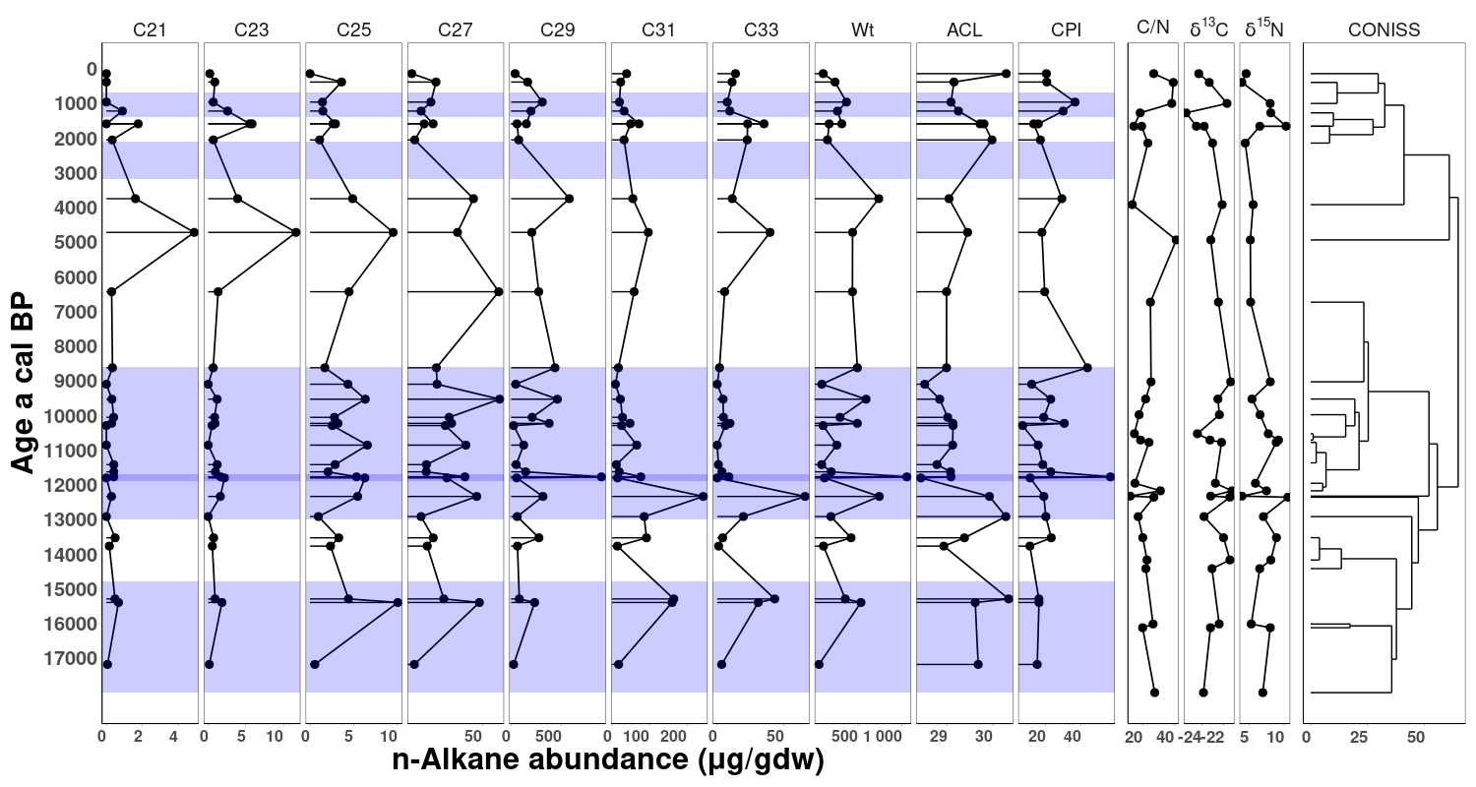Figure 4: Abundance of n-alkanes ( g/gdw) and 13C, 15N and C/N ratio values from fecal-pellet obtained of the palaeomiddens from Quebrada Incahuasi. A constrained cluster analysis by the method of incremental sum of squares (CONISS) was performed to see the relationships between the samples. The purple bands represent of the pluviometric anomalies CAPE I (ca. 18 to 14.8 ka cal BP), CAPE II (ca. 13.0 to 8.6 and 8.1 to 7.6 ka cal BP), ~2.5 and MCA (ca. 1.2 and 0.8 ka cal BP) described in the Atacama Desert. Note the different magnitudes of the abundances.

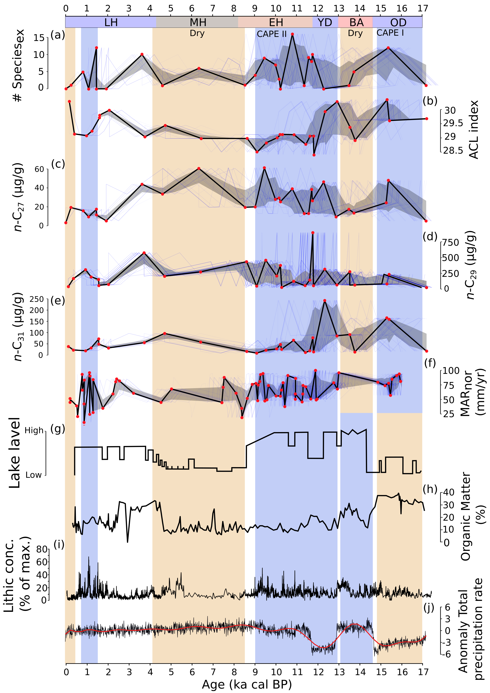Figure 5: Comparison of selected n-alkane abundances and macrofossil obtained from palaeomidden records with representative local, regional and global palaeoclimate records. (a) total number of extra-local species of macrofossil from palaeomiddens in Quebrada Incahuasi. (b) average chain length (ACL) of n-alkanes. (c-e) n-C27, n-C29 and n-C31 n-alkane abundances (g/gdw). (f) MAR anomalies in the central Atacama Desert (González-Pinilla et al., 2021). (g) Miscanti ancient lake level (Valero-Garcés et al., 1996; Grosjean et al., 2001, 23º44’S, 67º46’W, 4140 m asl). (h) Amount of organic matter from Junín lake (Rodbell et al.„ 2022, 4080 m asl).(i) Late Pleistocene-Holocene El Niño-like ENSO-sensitive marine records, from Peruvian shelf (Rein et al., 2005). (j) Transient simulation of precipitation (TraCE 21k-II, (He and Clark, 2022) over the central Atacama (24°S). From (a) to (f), the age-uncertainty median ensemble (estimated with the Banded Age Model in GeochronR package) is shown in black, with the 50% and 95% highest-density probability ranges shown in dark and light gray, respectively. (see Comboul et al., 2014; McKay et al., 2021 for more detail). OD: Oldest Dryas, BA: Bølling-Allerød, YD: Younger Dryas Stadial.

**References**

Anjos, L.J.S., de Toledo, P.M., 2018. Measuring resilience and assessing vulnerability of terrestrial ecosystems to climate change in South America. PLOS ONE 13, e0194654. doi:[10.1371/journal.pone.0194654](http://dx.doi.org/10.1371/journal.pone.0194654).

Arroyo, M.T.K., Armesto, J.J., Villagran, C., 1981. Plant Phenological Patterns in the High Andean Cordillera of Central Chile. Journal of Ecology 69, 205–223. doi:[10.2307/2259826](http://dx.doi.org/10.2307/2259826).

Arroyo, M.T.K., Squeo, F.A., Armesto, J.J., Villagran, C., 1988. Effects of Aridity on Plant Diversity in the Northern Chilean Andes: Results of a Natural Experiment. Annals of the Missouri Botanical Garden 75, 55–78. doi:[10.2307/2399466](http://dx.doi.org/10.2307/2399466).

Berdugo, M., Delgado-Baquerizo, M., Soliveres, S., Hernández-Clemente, R., Zhao, Y., Gaitán, J.J., Gross, N., Saiz, H., Maire, V., Lehmann, A., Rillig, M.C., Solé, R.V., Maestre, F.T., 2020. Global ecosystem thresholds driven by aridity. Science 367, 787–790. doi:[10.1126/science.aay5958](http://dx.doi.org/10.1126/science.aay5958).

Betancourt, J.L., Latorre, C., Rech, J.A., Quade, J., Rylander, K.A., 2000. A 22,000-Year Record of Monsoonal Precipitation from Northern Chile’s Atacama Desert. Science 289, 1542–1546. doi:[10.1126/science.289.5484.1542](http://dx.doi.org/10.1126/science.289.5484.1542).

Betancourt, J.L., Saavedra, B., 2002. Paleomadrigueras de roedores, un nuevo método para el estudio del Cuaternario en zonas áridas de Sudamérica. Revista chilena de historia natural 75, 527–546. doi:[10.4067/S0716-078X2002000300005](http://dx.doi.org/10.4067/S0716-078X2002000300005).

Borrelli, M.P., Holmgren, C.A., 2016. Dietary modifications of packrats in response to changing plant communities: Evidence from fossil plant cuticles spanning >55,000 years in Sonoran Desert packrat middens. Journal of Arid Environments 135, 1–8. doi:[10.1016/j.jaridenv.2016.08.004](http://dx.doi.org/10.1016/j.jaridenv.2016.08.004).

Braun-Blanquet, J. 1932. Plant sociology: the Study of Plant Communities. Transl. by G. D. Fuller and H. S. Conard. New York; NY: McGraw-Hill Book Co. 1–439

Bush, R.T., McInerney, F.A., 2013. Leaf wax n-alkane distributions in and across modern plants: Implications for paleoecology

and chemotaxonomy. Geochimica et Cosmochimica Acta 117, 161–179. doi:[10.1016/j.gca.2013.04.016](http://dx.doi.org/10.1016/j.gca.2013.04.016).

Carr, A.S., Boom, A., Grimes, H.L., Chase, B.M., Meadows, M.E., Harris, A., 2014. Leaf wax n-alkane distributions in arid zone South African flora: Environmental controls, chemotaxonomy and palaeoecological implications. Organic Geochemistry 67, 72–84. doi:[10.1016/j.orggeochem.2013.12.004](http://dx.doi.org/10.1016/j.orggeochem.2013.12.004).

Contreras, S., Landahur, M., García, K., Latorre, C., Reyers, M., Rethemeyer, J., Jaeschke, A., 2022. Leaf wax composition and distribution of Tillandsia landbeckii reflects moisture gradient across the hyperarid Atacama Desert. Plant Systematics and Evolution 308, 8. doi:[10.1007/s00606-021-01800-0](http://dx.doi.org/10.1007/s00606-021-01800-0).

Díaz, F.P., Frugone, M., Gutiérrez, R.A., Latorre, C., 2016. Nitrogen cycling in an extreme hyperarid environment inferred from d15 N analyses of plants, soils and herbivore diet. Scientific Reports 6, 22226. doi:[10.1038/srep22226](http://dx.doi.org/10.1038/srep22226).

Díaz, F.P., Latorre, C., Carrasco-Puga, G., Wood, J.R., Wilmshurst, J.M., Soto, D.C., Cole, T.L., Gutiérrez, R.A., 2019. Multiscale climate change impacts on plant diversity in the Atacama Desert. Global Change Biology 25, 1733–1745. doi:[10.1111/gcb.14583](http://dx.doi.org/10.1111/gcb.14583).

Díaz, F.P., Latorre, C., Maldonado, A., Quade, J., Betancourt, J.L., 2012. Rodent middens reveal episodic, long-distance plant colonizations across the hyperarid Atacama Desert over the last 34,000 years. Journal of Biogeography 39, 510–525. doi:[10.1111/j.1365-2699.2011.02617.x](http://dx.doi.org/10.1111/j.1365-2699.2011.02617.x).

Didyk, B.M., Simoneit, B.R.T., Brassell, S.C., Eglinton, G., 1978. Organic geochemical indicators of palaeoenvironmental conditions of sedimentation. Nature 272, 216–222. doi:[10.1038/272216a0](http://dx.doi.org/10.1038/272216a0).

Dunnington, D.W., Libera, N., Kurek, J., Spooner, I.S., Gagnon, G.A., 2022. tidypaleo: Visualizing paleoenvironmental archives using ggplot2. Journal of Statistical Software 101, 1–20. doi:[10.18637/jss.v101.i07](http://dx.doi.org/10.18637/jss.v101.i07).

Dussarrat, T., Prigent, S., Latorre, C., Bernillon, S., Flandin, A., Díaz, F.P., Cassan, C., Van Delft, P., Jacob, D., Varala, K., Joubes, J., Gibon, Y., Rolin, D., Gutiérrez, R.A., Pétriacq, P., 2022. Predictive metabolomics of multiple Atacama plant species unveils a core set of generic metabolites for extreme climate resilience. New Phytologist doi:[10.1111/nph.18095](http://dx.doi.org/10.1111/nph.18095).

Eglinton, G., 1973. Chemical fossils: A combined organic geochemical and environmental approach. Pure and Applied Chemistry 34, 611–632.

Eshel, G., Araus, V., Undurraga, S., Soto, D.C., Moraga, C., Montecinos, A., Moyano, T., Maldonado, J., Díaz, F.P., Varala, K., Nelson, C.W., Contreras-López, O., Pal-Gabor, H., Kraiser, T., Carrasco-Puga, G., Nilo-Poyanco, R., Zegar, C.M., Orellana, A., Montecino, M., Maass, A., Allende, M.L., DeSalle, R., Stevenson, D.W., González, M., Latorre, C., Coruzzi, G.M., Gutiérrez, R.A., 2021. Plant ecological genomics at the limits of life in the Atacama Desert. Proceedings of the National Academy of Sciences 118. doi:[10.1073/pnas.2101177118](http://dx.doi.org/10.1073/pnas.2101177118).

Feakins, S.J., Peters, T., Wu, M.S., Shenkin, A., Salinas, N., Girardin, C.A.J., Bentley, L.P., Blonder, B., Enquist, B.J., Martin, R.E., Asner, G.P., Malhi, Y., 2016. Production of leaf wax n-alkanes across a tropical forest elevation transect. Organic Geochemistry 100, 89–100. doi:[10.1016/j.orggeochem.2016.07.004](http://dx.doi.org/10.1016/j.orggeochem.2016.07.004).

Fornace, K.L., Hughen, K.A., Shanahan, T.M., Fritz, S.C., Baker, P.A., Sylva, S.P., 2014. A 60,000-year record of hydrologic variability in the Central Andes from the hydrogen isotopic composition of leaf waxes in Lake Titicaca sediments. Earth and Planetary Science Letters 408, 263–271. doi:[10.1016/j.epsl.2014.10.024](http://dx.doi.org/10.1016/j.epsl.2014.10.024).

Gayo, E.M., Latorre, C., Jordan, T.E., Nester, P.L., Estay, S.A., Ojeda, K.F., Santoro, C.M., 2012. Late Quaternary hydro-logical and ecological changes in the hyperarid core of the northern Atacama Desert (~ 21°S). Earth-Science Reviews 113, 120–140. doi:[10.1016/j.earscirev.2012.04.003](http://dx.doi.org/10.1016/j.earscirev.2012.04.003).

González-Pinilla, F.J., Latorre, C., Rojas, M., Houston, J., Rocuant, M.I., Maldonado, A., Santoro, C.M., Quade, J., Betan-court, J.L., 2021. High- and low-latitude forcings drive Atacama Desert rainfall variations over the past 16,000 years. Science Advances 7, eabg1333. doi:[10.1126/sciadv.abg1333](http://dx.doi.org/10.1126/sciadv.abg1333).

Grosjean, M., 2001. Mid-Holocene Climate in the South-Central Andes: Humid or Dry? Science 292, 2391–2391. doi:[10.1126/](http://dx.doi.org/10.1126/science.292.5526.2391a) [science.292.5526.2391a](http://dx.doi.org/10.1126/science.292.5526.2391a).

Grosjean, M., Núñez, A.L., 1994. Lateglacial, early and middle holocene environments, human occupation, and resource use in the Atacama (Northern Chile). Geoarchaeology 9, 271–286. doi:[10.1002/gea.3340090402](http://dx.doi.org/10.1002/gea.3340090402).

He, F., Clark, P.U., 2022. Freshwater forcing of the Atlantic Meridional Overturning Circulation revisited. Nature Climate Change 12, 449–454. doi:[10.1038/s41558-022-01328-2](http://dx.doi.org/10.1038/s41558-022-01328-2).

Hoffmann, B., Kahmen, A., Cernusak, L.A., Arndt, S.K., Sachse, D., 2013. Abundance and distribution of leaf wax n-alkanes in leaves of Acacia and Eucalyptus trees along a strong humidity gradient in northern Australia. Organic Geochemistry 62, 62–67. doi:[10.1016/j.orggeochem.2013.07.003](http://dx.doi.org/10.1016/j.orggeochem.2013.07.003).

Hogg, A.G., Heaton, T.J., Hua, Q., Palmer, J.G., Turney, C.S., Southon, J., Bayliss, A., Blackwell, P.G., Boswijk, G., Bronk Ramsey, C., et al., 2020. Shcal20 southern hemisphere calibration, 0–55,000 years cal bp. Radiocarbon 62, 759–778. doi:[10.1017/RDC.2020.59](http://dx.doi.org/10.1017/RDC.2020.59).

Houston, J., Latorre, C., 2022. The role of the non-stationary Andean Dry Diagonal in paleoclimate reconstructions. Hydro-logical Processes 36, e14723. doi:[10.1002/hyp.14723](http://dx.doi.org/10.1002/hyp.14723).

Howard, S., McInerney, F.A., Caddy-Retalic, S., Hall, P.A., Andrae, J.W., 2018. Modelling leaf wax n-alkane inputs to soils along a latitudinal transect across Australia. Organic Geochemistry 121, 126–137. doi:[10.1016/j.orggeochem.2018.03.013](http://dx.doi.org/10.1016/j.orggeochem.2018.03.013).

Inglis, G., Bhattacharya, T., Hemingway, J., Hollingsworth, E., Feakins, S., Tierney, J.E., 2022. Biomarker approaches for reconstructing terrestrial environmental change. Annual Review of Earth and Planetary Sciences 50, 369–394. doi: 10.1146/annurev-earth-032320-095943.

Juggins, S., 2022. rioja: Analysis of quaternary science data. Newcastle upon Tyne: University of Newcastle URL: <https://cran.r-project.org/package=rioja>. r package version 1.0-5.

Latorre, C., Betancourt, J.L., Arroyo, M.T.K., 2006. Late Quaternary vegetation and climate history of a perennial river canyon in the Río Salado basin (22°S) of Northern Chile. Quaternary Research 65, 450–466. doi:[10.1016/j.yqres.2006.02.002](http://dx.doi.org/10.1016/j.yqres.2006.02.002).

Latorre, C., Betancourt, J.L., Rylander, K.A., Quade, J., 2002. Vegetation invasions into absolute desert: A 45.000 yr rodent midden record from the Calama–Salar de Atacama basins, northern Chile (lat 22°–24°S). GSA Bulletin 114, 349–366. doi:[10.1130/0016-7606(2002)114<0349:VIIADA>2.0.CO;2](http://dx.doi.org/10.1130/0016-7606(2002)114<0349:VIIADA>2.0.CO;2).

Lewandowska, M., Keyl, A., Feussner, I., 2020. Wax biosynthesis in response to danger: Its regulation upon abiotic and biotic stress. New Phytologist 227, 698–713. doi:[10.1111/nph.16571](http://dx.doi.org/10.1111/nph.16571).

Li, R., Fan, J., Xue, J., Meyers, P.A., 2017. Effects of early diagenesis on molecular distributions and carbon isotopic composi-tions of leaf wax long chain biomarker n-alkanes: Comparison of two one-year-long burial experiments. Organic Geochemistry 104, 8–18. doi:[10.1016/j.orggeochem.2016.11.006](http://dx.doi.org/10.1016/j.orggeochem.2016.11.006).

Liu, Z., Otto-Bliesner, B.L., He, F., Brady, E.C., Tomas, R., Clark, P.U., Carlson, A.E., Lynch-Stieglitz, J., Curry, W., Brook, E., Erickson, D., Jacob, R., Kutzbach, J., Cheng, J., 2009. Transient Simulation of Last Deglaciation with a New Mechanism for Bølling-Allerød Warming. Science 325, 310–314. doi:[10.1126/science.1171041](http://dx.doi.org/10.1126/science.1171041).

Lüning, S., Gałka, M., Bamonte, F.P., Rodríguez, F.G., Vahrenholt, F., 2019. The Medieval Climate Anomaly in South America. Quaternary International 508, 70–87. doi:[10.1016/j.quaint.2018.10.041](http://dx.doi.org/10.1016/j.quaint.2018.10.041).

Martin, L.C.P., Blard, P.H., Lavé, J., Condom, T., Prémaillon, M., Jomelli, V., Brunstein, D., Lupker, M., Charreau, J., Mariotti, V., Tibari, B., ASTER Team, Davy, E., 2018. Lake Tauca highstand (Heinrich Stadial 1a) driven by a southward shift of the Bolivian High. Science Advances 4, eaar2514. doi:[10.1126/sciadv.aar2514](http://dx.doi.org/10.1126/sciadv.aar2514).

Mörchen, R., Amelung, W., Giese, C., Böhnert, T., Ruhm, J., Lehndorff, E., 2021. Fingerprint of plant life in the Atacama Desert – Insights from n-alkane analyses. Organic Geochemistry 151, 104145. doi:[10.1016/j.orggeochem.2020.104145](http://dx.doi.org/10.1016/j.orggeochem.2020.104145).

Moreno, A., Giralt, S., Valero-Garcés, B., Sáez, A., Bao, R., Prego, R., Pueyo, J.J., González-Sampériz, P., Taberner, C., 2007. A 14kyr record of the tropical Andes: The Lago Chungará sequence (18°S, northern Chilean Altiplano). Quaternary International 161, 4–21. doi:[10.1016/j.quaint.2006.10.020](http://dx.doi.org/10.1016/j.quaint.2006.10.020).

Mucina, L., 2019. Biome: Evolution of a crucial ecological and biogeographical concept. New Phytologist 222, 97–114. doi:[10.1111/nph.15609](http://dx.doi.org/10.1111/nph.15609).

Navarro, J., Powers, J.M., Paul, A., Campbell, D.R., 2022. Phenotypic plasticity and selection on leaf traits in response to snowmelt timing and summer precipitation. New Phytologist 234, 1477–1490. doi:[10.1111/nph.18084](http://dx.doi.org/10.1111/nph.18084).

Nester, P.L., Gayó, E., Latorre, C., Jordan, T.E., Blanco, N., 2007. Perennial stream discharge in the hyperarid Atacama Desert of northern Chile during the latest Pleistocene. Proceedings of the National Academy of Sciences 104, 19724–19729. doi:[10.1073/pnas.0705373104](http://dx.doi.org/10.1073/pnas.0705373104).

Nieto-Moreno, V., Rohrmann, A., van der Meer, M.T.J., Sinninghe Damsté, J.S., Sachse, D., Tofelde, S., Niedermeyer, E.M., Strecker, M.R., Mulch, A., 2016. Elevation-dependent changes in n-alkane D and soil GDGTs across the South Central Andes. Earth and Planetary Science Letters 453, 234–242. doi:[10.1016/j.epsl.2016.07.049](http://dx.doi.org/10.1016/j.epsl.2016.07.049).

Núñez, L., Grosjean, M., Cartajena, I., 2002. Human Occupations and Climate Change in the Puna de Atacama, Chile. Science 298, 821–824. doi:[10.1126/science.1076449](http://dx.doi.org/10.1126/science.1076449).

Obase, T., Abe-Ouchi, A., 2019. Abrupt Bølling-Allerød Warming Simulated under Gradual Forcing of the Last Deglaciation. Geophysical Research Letters 46, 11397–11405. doi:[10.1029/2019GL084675](http://dx.doi.org/10.1029/2019GL084675).

Pollard, M., Beisson, F., Li, Y., Ohlrogge, J.B., 2008. Building lipid barriers: Biosynthesis of cutin and suberin. Trends in Plant Science 13, 236–246. doi:[10.1016/j.tplants.2008.03.003](http://dx.doi.org/10.1016/j.tplants.2008.03.003).

Quade, J., Rech, J.A., Betancourt, J.L., Latorre, C., Quade, B., Rylander, K.A., Fisher, T., 2008. Paleowetlands and regional climate change in the central Atacama Desert, northern chile. Quaternary Research 69, 343–360. doi:[10.1016/j.yqres.](http://dx.doi.org/10.1016/j.yqres.2008.01.003) [2008.01.003](http://dx.doi.org/10.1016/j.yqres.2008.01.003).

Rabatel, A., Francou, B., Jomelli, V., Naveau, P., Grancher, D., 2008. A chronology of the Little Ice Age in the tropical Andes of Bolivia (16°S) and its implications for climate reconstruction. Quaternary Research 70, 198–212. doi:[10.1016/j.yqres.](http://dx.doi.org/10.1016/j.yqres.2008.02.012) [2008.02.012](http://dx.doi.org/10.1016/j.yqres.2008.02.012).

Rech, J.A., Quade, J., Betancourt, J.L., 2002. Late Quaternary paleohydrology of the central Atacama Desert (lat 22°–24°S), Chile. GSA Bulletin 114, 334–348. doi:[10.1130/0016-7606(2002)114<0334:LQPOTC>2.0.CO;2](http://dx.doi.org/10.1130/0016-7606(2002)114<0334:LQPOTC>2.0.CO;2).

Rein, B., Lückge, A., Reinhardt, L., Sirocko, F., Wolf, A., Dullo, W.C., 2005. El Niño variability off Peru during the last 20,000 years. Paleoceanography 20, PA4003. doi:[10.1029/2004PA001099](http://dx.doi.org/10.1029/2004PA001099).

Rodbell, D.T., Hatfield, R.G., Abbott, M.B., Chen, C.Y., Woods, A., Stoner, J.S., McGee, D., Tapia, P.M., Bush, M., Valero-Garcés, B.L., Lehmann, S.B., Mark, S.Z., Weidhaas, N.C., Hillman, A.L., Larsen, D.J., Delgado, G., Katz, S.A., Solada, K.E., Morey, A.E., Finkenbinder, M., Valencia, B., Rozas-Davila, A., Wattrus, N., Colman, S.M., Bustamante, M.G., Kück, J., Pierdominici, S., 2022. 700,000 years of tropical Andean glaciation. Nature 607, 301–306. doi:[10.1038/s41586-022-04873-0](http://dx.doi.org/10.1038/s41586-022-04873-0).

Rondanelli, R., Molina, A., Falvey, M., 2015. The Atacama Surface Solar Maximum. Bulletin of the American Meteorological Society 96, 405–418. doi:[10.1175/BAMS-D-13-00175.1](http://dx.doi.org/10.1175/BAMS-D-13-00175.1).

Sachse, D., Radke, J., Gleixner, G., 2006. δD values of individual n-alkanes from terrestrial plants along a climatic gradient– Implications for the sedimentary biomarker record. Organic Geochemistry 37, 469–483. doi:[10.1016/j.orggeochem.2005.](http://dx.doi.org/10.1016/j.orggeochem.2005.12.003) [12.003](http://dx.doi.org/10.1016/j.orggeochem.2005.12.003).

Schneider, T., Bischoff, T., Haug, G.H., 2014. Migrations and dynamics of the intertropical convergence zone. Nature 513, 45–53. doi:[10.1038/nature13636](http://dx.doi.org/10.1038/nature13636).

Shepherd, T., Wynne Griﬀiths, D., 2006. The effects of stress on plant cuticular waxes. New Phytologist 171, 469–499.doi:[10.1111/j.1469-8137.2006.01826.x](http://dx.doi.org/10.1111/j.1469-8137.2006.01826.x).

Smith, F.A., Freeman, K.H., 2006. Influence of physiology and climate on δD of leaf wax n-alkanes from C3 and C4 grasses. Geochimica et Cosmochimica Acta 70, 1172–1187. doi:[10.1016/j.gca.2005.11.006](http://dx.doi.org/10.1016/j.gca.2005.11.006).

Spaulding, W.G., 1990. Vegetational and climatic development of the mojave desert: The last glacial maximum. Packrat middens: the last 40,000 years of biotic change. In Packrat Middens: The Last 40,000 Years of Biotic Change; Betancourt, J.L., Van Devender, T.R., Martin, P.S., Eds. University of Arizona Press: Tucson, AZ, USA. 166–99.

Stotz, G.C., Salgado-Luarte, C., Escobedo, V.M., Valladares, F., Gianoli, E., 2021. Global trends in phenotypic plasticity of plants. Ecology Letters 24, 2267–2281. doi:[10.1111/ele.13827](http://dx.doi.org/10.1111/ele.13827).

Stríkis, N.M., Cruz, F.W., Barreto, E.A.S., Naughton, F., Vuille, M., Cheng, H., Voelker, A.H.L., Zhang, H., Karmann, I., Edwards, R.L., Auler, A.S., Santos, R.V., Sales, H.R., 2018. South American monsoon response to iceberg discharge in the North Atlantic. Proceedings of the National Academy of Sciences 115, 3788–3793. doi:[10.1073/pnas.1717784115](http://dx.doi.org/10.1073/pnas.1717784115).

Teunissen van Manen, M.L., Jansen, B., Cuesta, F., León-Yánez, S., Gosling, W.D., 2020. From leaf to soil: N-alkane signal preservation, despite degradation along an environmental gradient in the tropical Andes. Biogeosciences 17, 5465–5487. doi:[10.5194/bg-17-5465-2020](http://dx.doi.org/10.5194/bg-17-5465-2020).

Tipple, B.J., Pagani, M., 2013. Environmental control on eastern broadleaf forest species’ leaf wax distributions and D/H ratios. Geochimica et Cosmochimica Acta 111, 64–77. doi:[10.1016/j.gca.2012.10.042](http://dx.doi.org/10.1016/j.gca.2012.10.042).

Valero-Garcés, B.L., Grosjean, M., Schwalb, A., Geyh, M., Messerli, B., Kelts, K., 1996. Limnogeology of Laguna Miscanti: Evidence for mid to late Holocene moisture changes in the Atacama Altiplano (Northern Chile). Journal of Paleolimnology 16, 1–21. doi:[10.1007/BF00173268](http://dx.doi.org/10.1007/BF00173268).

Villagrán, C., Armesto, J.J., Kalin Arroyo, M.T., 1981. Vegetation in a high Andean transect between Turi and Cerro León in Northern Chile. Vegetatio 48, 3–16. doi:[10.1007/BF00117356](http://dx.doi.org/10.1007/BF00117356).

Wang, J., Axia, E., Xu, Y., Wang, G., Zhou, L., Jia, Y., Chen, Z., Li, J., 2018. Temperature effect on abundance and distribution of leaf wax n-alkanes across a temperature gradient along the 400 mm isohyet in China. Organic Geochemistry 120, 31–41. doi:[10.1016/j.orggeochem.2018.03.009](http://dx.doi.org/10.1016/j.orggeochem.2018.03.009).

Wickham, H., 2016. ggplot2: Elegant graphics for data analysis. Wiley interdisciplinary reviews: computational statistics URL: [https://ggplot2.tidyverse.org](https://ggplot2.tidyverse.org/).

Wickham, H., Averick, M., Bryan, J., Chang, W., McGowan, L.D., François, R., Grolemund, G., Hayes, A., Henry, L., Hester, J., Kuhn, M., Pedersen, T.L., Miller, E., Bache, S.M., Müller, K., Ooms, J., Robinson, D., Seidel, D.P., Spinu, V., Takahashi, K., Vaughan, D., Wilke, C., Woo, K., Yutani, H., 2019. Welcome to the tidyverse. Journal of Open Source Software 4, 1686. doi:[10.21105/joss.01686](http://dx.doi.org/10.21105/joss.01686).

Wong, M.L., Wang, X., Latrubesse, E.M., He, S., Bayer, M., 2021. Variations in the South Atlantic Convergence Zone over the mid-to-late Holocene inferred from speleothem 18O in central Brazil. Quaternary Science Reviews 270, 107178. doi:[10.1016/j.quascirev.2021.107178](http://dx.doi.org/10.1016/j.quascirev.2021.107178).

Workman, T.R., Rech, J.A., Gayó, E.M., Santoro, C.M., Ugalde, P.C., De Pol-Holz, R., Capriles, J.M., Latorre, C., 2020. Landscape evolution and the environmental context of human occupation of the southern pampa del tamarugal, Atacama Desert, Chile. Quaternary Science Reviews 243, 106502. doi:[10.1016/j.quascirev.2020.106502](http://dx.doi.org/10.1016/j.quascirev.2020.106502).

Wu, M.S., West, A.J., Feakins, S.J., 2019. Tropical soil profiles reveal the fate of plant wax biomarkers during soil storage. Organic Geochemistry 128, 1–15. doi:[10.1016/j.orggeochem.2018.12.011](http://dx.doi.org/10.1016/j.orggeochem.2018.12.011).